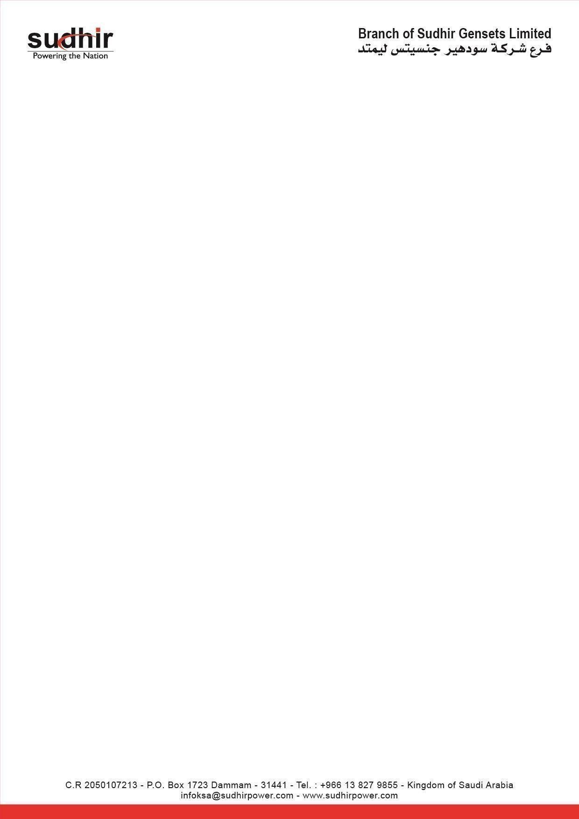
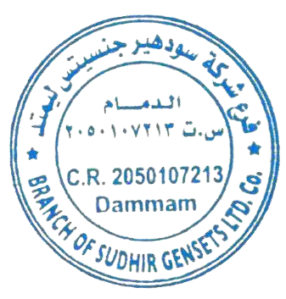
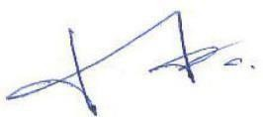

Ownership Certificate

To Whom It May Concern

This is to certify that the following equipment mentioned below are the sole owned by
Branch of Sudhir Gensets LTD.

Equipment | Diesel Soundproof Generator
Brand / Make | PERKINS
Asset ID | SG-426-650
Model Number | VEPL-650-CDP
Serial Number | VEPL/2019-20/0047
Engine Serial Number | JGBF5005N06716E
Alternator Serial Number | N20A030952
Rating | 650 KVA / 520 KW

Mansoor Ali Branch Manager
Branch of Sudhir Gensets LTD. Co Dammam - KSA

